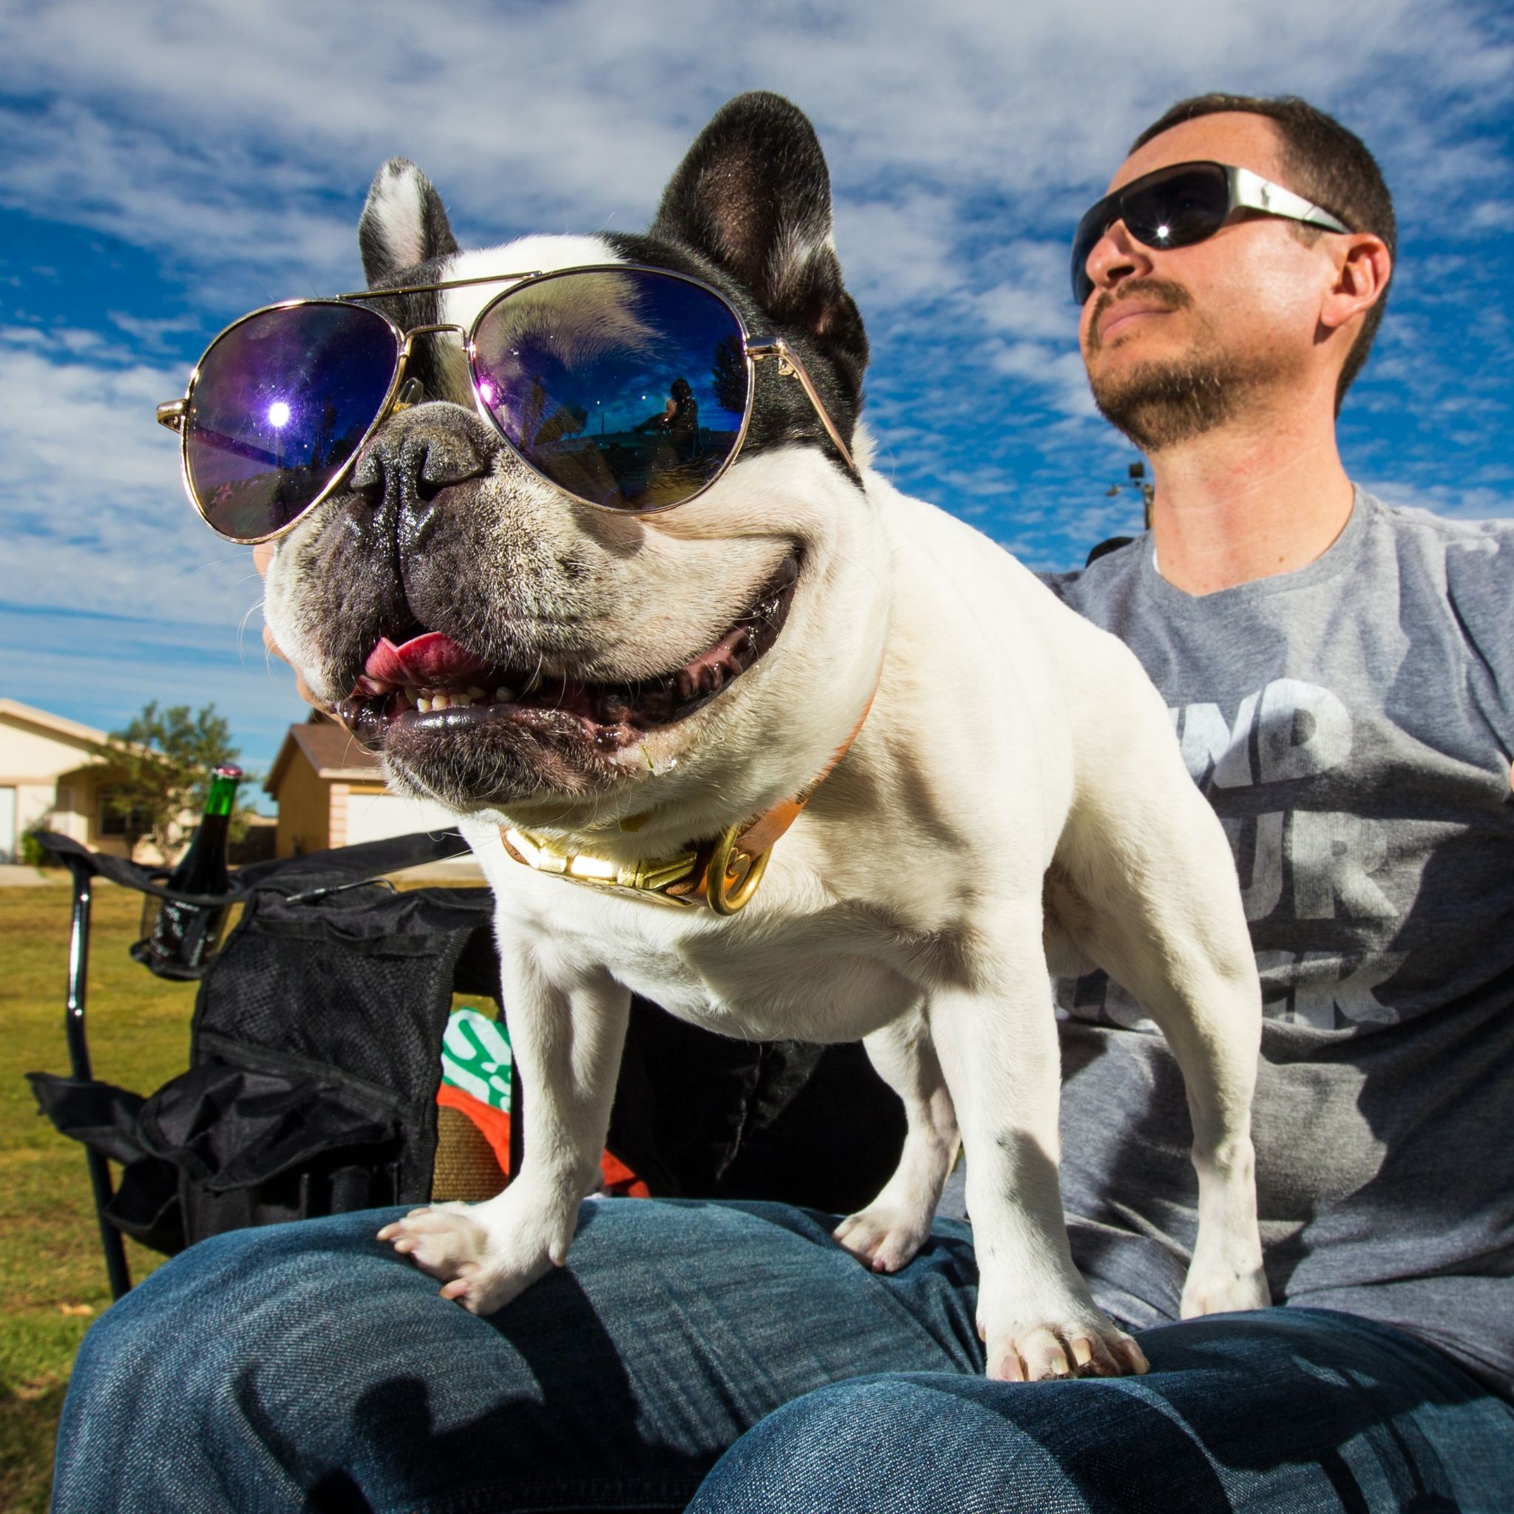
Photo Credit: Daniel Lloyd Blunk Fernandez via Unsplash

How to Care for and Make Your Dog More Comfortable in Their Later Years

As pet owners, there is nothing more important in the world than the health and safety of our furry friends. They are the companions that never leave our side, and we owe them everything. That is why it can be sad when they get older and/or become handicapped. However, you can take the proper steps to ensure that they are as healthy as possible during their senior years. Today, Dud’s Frenchie Clothing offers some tips to keep them comfortable and happy.

Stay Active with Your Pet
Your senior dog likely can’t run around like they used to, but that doesn’t mean that you shouldn’t be taking them on walks or playing in the yard with them. Even a slow, leisurely walk around your neighborhood or other walk-friendly area can give your pet much needed exercise and an opportunity to use their nose. Sniffing is incredibly important for dogs and new places are perfect opportunities for them to get this kind of mental stimulation.

You might want to invest in some doggie shoes from Dud’s Frenchie Clothing if you live in a hot area. It’s important to protect their feet, but Dud’s can ensure they look fantastic, too!

It can be helpful to understand the ailments common to your pet’s breed so you can watch for signs of issues like hip dysplasia, arthritis, or skin conditions which can be especially prominent as they age. Take these conditions into consideration when you choose how long to walk and where to go. For instance, hills might not be possible for some aging pets and the local botanical garden could wreak havoc on your pet’s allergies.

Keep Your Pet Clean with Quality Shampoo
Since your pet may be handicapped or otherwise immobile, you will need to do everything you can to make sure they are clean and healthy. Urine, drool, and dirt in general can be irritating and cause infections. A good first step is to wash their hair with a high-quality shampoo that will leave their coat clean without inflaming their skin.

If you are unsure where to start, then consider looking online at reviews of the best dog shampoos and read what other customers have said. You can also ask your veterinarian if they recommend a certain shampoo and conditioner for your pet and their health condition.

Tips for Administering Medication
There are different tips that you can use to give your aging pet medication, depending on their illness and condition. If your pet needs one pill a day and they scoff at the medicine, then you can hide it in a piece of food. Peanut butter and bread usually do the trick.

If your pet requires numerous doses of medication throughout the day, then you may need to take a more direct approach, especially if they don’t have an appetite. You can first check to see if the pills come in a flavored form that will trick the pet into taking them. You can also try using a pill gun, which is like a syringe that you use at their throat. When all else fails, have someone help you calm the animal, so they are not as worked up during the process.

Remember That Your Anxiety Can Rub Off on Your Pet
Although we want to do everything possible to care for our pets, it is also important that we take care of ourselves. If we don’t get enough sleep or we work all of the time then we can become mentally and physically unwell, and if that happens, then we can easily become stressed. We may not realize it, but that anxiety can rub off on your pet because when we are unhappy, then they can also get upset. If you notice signs of aggressive behavior, excessive urination, or sudden changes in their eating habits, then you may need to change your lifestyle so they can change theirs.

Working at the office too much can often be a problem because then your pet is home alone, and in addition to having feelings of isolation, they don’t may not be getting the care that they need. So, consider asking your company about a hybrid schedule where you work part of the week at the office and the other part at home. You could also hire a qualified sitter to visit your home throughout the week so they can tend to your pet’s needs. This is especially important for handicapped or paralyzed pets.

Use Resources to Pay for Veterinary Care
While all pets age, when you pair that with a handicap, then your veterinary bills can quickly escalate, and it can be hard to manage. If you are having trouble making ends meet, then consider looking at alternative options, like calling a veterinary college to see if they offer special rates. Another option is to ask if your vet uses a service like Care Credit, which allows you to pay the balance over time. Finally, look for charitable organizations, like the Brown Dog Foundation, which may have programs that can help you out.

You can also look into insurance. When searching for pet insurance, take advantage of sites that can make the comparisons a little easier when comparing ratings and reviews. After all, it can be difficult to know where to begin researching pet insurance plans, so it is helpful to get information and advice from reliable sources. Once armed with knowledge of the different types of plans available, you will want to compare them side-by-side in order to make the best choice for your four-legged friend.

When looking into pet insurance policies, investigate the coverage range, any limitations or restrictions the policy may impose, and if veterinary care costs are included. Ultimately, choosing a reputable company with a plan that fits your needs will ensure that your pet is covered in any medical situation while also helping you keep out-of-pocket costs down.

Give Your Senior Pet the Care They Deserve
As you can see, there are ways to help your older handicapped pet feel good and live out their years as comfortably as possible. Consider buying a good shampoo, controlling your own stress, pet insurance, and learning to administer medication, and you’ll be on the right path.

